**Patent Search and Analysis Report (PSAR)**

**submitted as a part of the**

**PROJECT REPORT**

***Stocker***

***Submitted by***

**Kanan Anadkat – 171160107002**

**Hetvi Gandhi – 171160107018**

**Pranav Joshi – 171160107029**

**Brijesh Shukla – 171160107052**

***In partial fulfilment for the award of the degree of***

**BACHELOR OF ENGINEERING**

***in***

**Computer Engineering**

**Marwadi Education Foundation-Faculty of PG Studies**

**& Res. In Engineering & Technology, Rajkot**

 

**Gujarat Technological University, Ahmedabad**

(2020-2021) 

**Marwadi Education Foundation-Faculty of PG Studies**

**& Res. In Engineering & Technology, Rajkot**

Computer Engineering Department

**(2020-2021)**

**CERTIFICATE**

This is to certify that the Search and Analysis Report (PSAR), submitted along with the project entitled **Stocker** has been carried out by **Kanan Anadkat (171160107002)** under my guidance in partial fulfillment for the degree of Bachelor of Engineering in Computer Engineering 7th Semester of Gujarat Technological University, Ahmadabad during the academic year 2017-18.

Date : ____________________

**Internal Guide Head of the Department**

Prof. Shaktirajsinh Jadeja Prof. Jay Teraiya

Assistant Professor Head of Department

 

**Marwadi Education Foundation-Faculty of PG Studies**

**& Res. In Engineering & Technology, Rajkot**

Computer Engineering Department

**(2020-2021)**

**CERTIFICATE**

This is to certify that the Search and Analysis Report (PSAR), submitted along with the project entitled **Stocker** has been carried out by **Hetvi Gandhi (171160107018)** under my guidance in partial fulfillment for the degree of Bachelor of Engineering in Computer Engineering 7th Semester of Gujarat Technological University, Ahmadabad during the academic year 2017-18.

Date : ____________________

**Internal Guide Head of the Department**

Prof. Shaktirajsinh Jadeja Prof. Jay Teraiya

Assistant Professor Head of Department

 

**Marwadi Education Foundation-Faculty of PG Studies**

**& Res. In Engineering & Technology, Rajkot**

Computer Engineering Department

**(2020-2021)**

**CERTIFICATE**

This is to certify that the Search and Analysis Report (PSAR), submitted along with the project entitled **Stocker** has been carried out by **Pranav Joshi (171160107029)** under my guidance in partial fulfillment for the degree of Bachelor of Engineering in Computer Engineering 7th Semester of Gujarat Technological University, Ahmadabad during the academic year 2017-18.

Date : ____________________

**Internal Guide Head of the Department**

Prof. Shaktirajsinh Jadeja Prof. Jay Teraiya

Assistant Professor Head of Department

 

**Marwadi Education Foundation-Faculty of PG Studies**

**& Res. In Engineering & Technology, Rajkot**

Computer Engineering Department

**(2020-2021)**

**CERTIFICATE**

This is to certify that the Search and Analysis Report (PSAR), submitted along with the project entitled **Stocker** has been carried out by **Brijesh Shukla (171160107052)** under my guidance in partial fulfillment for the degree of Bachelor of Engineering in Computer Engineering 7th Semester of Gujarat Technological University, Ahmadabad during the academic year 2017-18.

Date : ____________________

**Internal Guide Head of the Department**

Prof. Shaktirajsinh Jadeja Prof. Jay Teraiya

Assistant Professor Head of Department

 

**Marwadi Education Foundation-Faculty of PG Studies**

**& Res. In Engineering & Technology, Rajkot**

Computer Engineering Department

**(2020-2021)**

**DECLARATION**

We hereby declare that the Patent Search and Analysis Report (PSAR), submitted along with the Project Report for the project entitled “**Stocker”** in partial fulfillment for the degree of Bachelor of Engineering in Computer Engineering to Gujarat Technological University, Ahmedabad, is a bonafide record of the project work carried out at**Marwadi Education Foundation-Fucult of PG Studies & Res. In Engineering & Technology, Rajkot** under the supervision of (Internal Guide Name) and that no part of any of these PSAR report has been directly copied from any students’ reports or taken from any other source, without providing due reference.

**Name of the Students Sign of Students**

**1. Kanan Anadkat 171160107002**

**2. Hetvi Gandhi 171160107018**

**3. Pravan Joshi 171160107029**

**4. Brijesh Shukla 171160107052**

**Contents**

**Acknowledgements 8**

**Abstract 9**

**List of Figures 10**

1. **Introduction 11-12**
   1. Document purpose 11
   2. Product scope 11
   3. Intended audience and document overview 11
   4. Definitions, acronyms and abbreviations 11
   5. Document conventions 12
   6. References and acknowledgments 12
2. **Overall description 13-14**
   1. Product perspective 13
   2. Product functionality 13
   3. Users and characteristics 13
   4. Operating environment 13
   5. Design and implementation constraints 13
   6. User documentation 14
   7. Assumptions and dependencies 14
3. **Specific requirements 15-16**
   1. External interface requirements 15
   2. Functional requirements 16
   3. Behavior requirements 16
4. **Other non-functional requirements 17**
   1. Performance requirements 17
   2. Safety and security requirements 17
   3. Software quality attributes 17

**Appendix A – Design Engineering Canvas 18-28**

**Appendix B – System Design 29-34**

**Appendix C - Data Dictionary 35**

**Appendix D – Periodic Progress Reports 36-43**

**Appendix E – Plagiarism Report 44**

**Acknowledgements**

We would like to extend our hearty thanks with a deep sense of gratitude and respect to all those who provides us immense help and guidance during our project.

We would like to thank our Head of Department for providing a vision about the system. We have been greatly benefited from their regular critical reviews and inspiration throughout my work.

We would like to express our sincere thanks to our internal guide Prof. Shaktirajsinh jadeja and who gave us an opportunity to undertake such a challenging and great innovative work. We are grateful to them for their guidance, encouragement, understanding and insightful support in the development process.

Last but not the least we would like to mention here that we are greatly indebted to each and everybody who has been associated with our project at any stage but whose name does not find a place in this acknowledgement.

**Abstract**

This is interesting machine learning project in this project we will make one website or software. In this we will plane for the predict the future price of the stock market. in this we will using frontend ,backend an as well as the graph plotting using machine learning we will use HTML, CSS, JS and PHP for frontend developing and for backend python, machine learning and django as well as flask and for database we will use the my SQL or SQLite or any another dataset to storing the data and to hosting this website we will use Xamp server This is also use full for that he/she is new to stock market and in this project we will set some advanced level features like you will trading directly from here or using graph our software or website is giving some advice to user to stay ,to buy of go for sell in this data will fetch form official site of BSE of NSE in every 2 second so this is brief idea of our website.

**List of Figures**

|  |  |  |
| --- | --- | --- |
| **NO.** | **Name** | **Pg. No.** |
| **1.** | **Use Case** | **29** |
| **2.** | **Sequences Diagram** | **30** |
| **3.** | **Class Diagram** | **31** |
| **4.** | **Activity Diagram** | **32** |
| **5.** | **DFD** | **33-34** |
|  | **A. Level 0** | **33** |
|  | **B. Level 1** | **34** |

1. **Introduction**

## Document Purpose

## This Document is based on the details of our software name as the “Stoker” which is the online base portal which has the mainly two modules user (buyer, seller), Admin.

## This Document contains all of the information regarding the software that which is the requirements and other details as well.

## Product Scope

The main aim of this product is to buying and selling shares in stock market form the paper

based to the digital.

In this project we will create one software in this we will provide the graph of that stock using ml that give user to per second analysis and we will provide some advice from that graph and we will fetch data from that official website of BSE or NSE of that stock and we will fetch the data per second.

## Intended Audience and Document Overview

This Document is useful for all those who want to invest in the stock market and for those who are investing. This software also provides expert advice which will be useful for people and it also includes daily weekly and motherly updates of stock market.

Here people can also manage their portfolio by sharing this stocks information and even if people see exert advice from this information.

## Definitions, Acronyms and Abbreviations

“Stocker” Name itself is that this software is a stock market related software and anyone who wants to invest in the stock market or sell their stock can do so. And they can also take expert advice if they won’t and also manage their stock portfolio.

## Document Conventions

The formatting convention is used as the fonts are size 11 or 12 written in Time New Roman.

All the highlighted words are written in Bold.

## References and Acknowledgments

* To create UML Diagram: **https://www.lucidchart**.**com**
* As our project is team project have to work in centralize manner we have used GitHub (**https://github.com**) And Stack Overflowl (**https://stackoverflow.com**)

1. **Overall Description**

## Product Perspective

Main aim to develop this system is to give the perfect prediction of each and every stock. This system also allows to get a expert advice from the expert. Get stock information easily. User can keep track of each stock which he/she can invest their money. User friendly, to enhance the corresponding between the user and expert and also they can't lose money.

## Product Functionality

* Check all the stocks.
* Invest money in the stocks and get better investment.
* Can have a view on portfolio
* Also have a view on all stocks in which users are invest their money.

Register

Login

Feedback

## Users and Characteristics

Every type of user of the system who are already registered with the "stocker" system are the users of the system. For example , the admin user of the system can monitor the system like manage the stocks , manage user and manage user activity etc. The customer users are those who are already register can perform the task like view all the stocks and keep track of all the activities in their portfolio and also invest on the stocks etc. Developer user is there who technically developed and maintain system. Testers who test the system.

## Operating Environment

It is python and ML based software so develop this software python environment is required, here we are using pycharm code editor and for ML coding part Anaconda navigator based Jupyter book is important

## Design and Implementation Constraints

Firstly, we have designed the prototype of project using cacoo wireframe so that every team member must have the clear idea of the project (User Interface ) and can discuss with people before stating with the actual project development. As website be used in any device so more focus on the responsiveness of the website so that user will have great experience with any device.

## User Documentation

With this project you will get a chat with the experts only which may help the users with the questions you have. Also will provide the user portfolio where user can see all the past activities done by them.

## Assumptions and Dependencies

* Dependencies
* The entire project depends on end-user's operation.
* They should possess enough knowledge to work with the system
* Assumption:
* End-user is the person having enough knowledge for the project operation.
* Only administration person has all the privileges.
* The database is correct and up-to date with every time.
* The availability and reliability of the system is the level which user wants it.
* The user of the system must be award about the various functionalities of the system and all the operation of it.

1. **Specific Requirements**

## External Interface Requirements

### User Interfaces

The user is required to select which company is he interested in amongst the various companies that have been provided. Software interface: software is based on an anaconda environment also jupyter notebook is used to combine software code, computational output and multimedia resources in a single document. Data analysis tools like Tiingo is also used to create API'S and also data fetch. It can also generate 250 keys per day and generate. csv file. Now we are developing just a software but in future when we create a website then database SQLITE is required. Hardware interface: It can be done through laptop/pc, mobile, tablet. Web hosting makes the file that comprise a website (code, images) available for viewing online and it is hosted on a server. Communication interface: Grounded on communication theories, we propose to use a data mining algorithm to detect communication patterns within a company to determine if such patterns may reveal performance of the company, meaningful information of corporate performance as reflected by such indicators as stock market performance.

The user is required to select which company is he interested in amongst the various companies that have been provided.

### Hardware Interfaces

It can be done through laptop/pc, mobile, tablet. Web hosting makes the file that comprise a website (code, images) available for viewing online and it is hosted on a server.

### Software Interfaces

software is based on an anaconda environment also jupyter notebook is used to combine software code, computational output and multimedia resources in a single document. Data analysis tools like Tiingo is also used to create API'S and also data fetch. It can also generate 250 keys per day and generate. csv file. Now we are developing just a software but in future when we create a website then database SQLITE is required.

### Communications Interfaces

Grounded on communication theories, we propose to use a data mining algorithm to detect communication patterns within a company to determine if such patterns may reveal performance of the company, meaningful information of corporate performance as reflected by such indicators as stock market performance.

## Functional Requirements

Stock market cannot be accurately predicted. The future, like any complex problem, has far too many variables to be predicted. It is a place where buyers and sellers converge. There are some fundamental indicators like price to earning ratio, price to sales ratio, Cash flow ratio by which a company's stock value can be predicted. Objective of system is to give a approximate idea of where stock market might be headed. It does not give a long term forecasting of a stock value. Requirements that system needs is categorized into functional and non-functional requirements. Functional requirements are functions that must be included in any system to satisfy the business needs and be acceptable to users like such as The system should be able to generate an approximate share price. Non-functional requirements are bases on the performance, information, economy, control and security efficiency and services.

It follows such as:

1) The system should provide better accuracy.

2) The system should have simple interface for users to use.

3) To perform efficiently in short amount of time.

## Behaviour Requirements

### Use Case View

The purpose of the use case diagrams is simply to provide the high level view of the system and convey the requirements in laypeople's terms for the stakeholders. Additional diagrams and documentation can be used to provide a complete functional and technical view of the system.

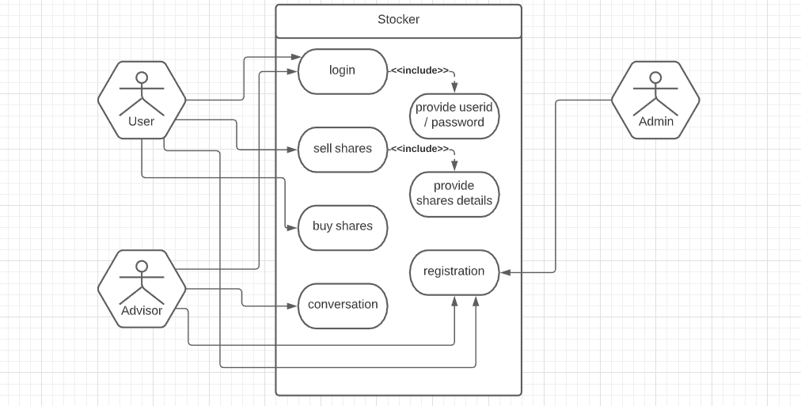

1. **Other Non-functional Requirements**

## Performance Requirements

Problem is the initial stage of a Computer Vision/ML project, and it focuses on gaining an understanding of the problem poised to be solved by applying ML

A combination of an understanding of the problem, unified with proposed solutions, and available data, will enable a suitable ML model selection process to achieve the ideal solution result.

Not any specific requirement from user of peoples, but general suggestions are there must have easy interface so that one can easily understand everything so it become helpful also regular load time is quite acceptable but not take more time.

## Safety and Security Requirements

As it is stock market prediction portal so not that much security related requirements but data must be safe means data must not be got leak because which may create to issue and also data must be safe in terms of storage means data must not be loss, it must be backed up properly because data loss may create great issue.

ML systems require three sets of data:

• Training data to build a predictive model

• Testing data to assess how well the model works

• Live transactional or operational data when the model is put to work

Many of the principles used to protect data in other systems can be applied to ML projects, including anonymization, tokenization and encryption. The first step is to ask if the data is needed. It's tempting, when preparing for AI and ML projects, to collect all the data possible and then see what can be done with it.

## Software Quality Attributes

Quantification of parameters affecting the software quality is one of the important aspects of research in the field of software engineering Quality software is reasonably bugs or defects free, delivered on time and within budget, meets requirements and/or expectations, and is maintainable. Software quality means a degree to which software or a process meets customer and user needs or expectations.

The summarized software to deal with properties such as complexity is cyclic in nature, cohesion i.e. the properties of function which meets customers of the needs and provide product satisfaction.

**Appendix A – Design Engineering Canvas**

1. **AEIOU Canvas**

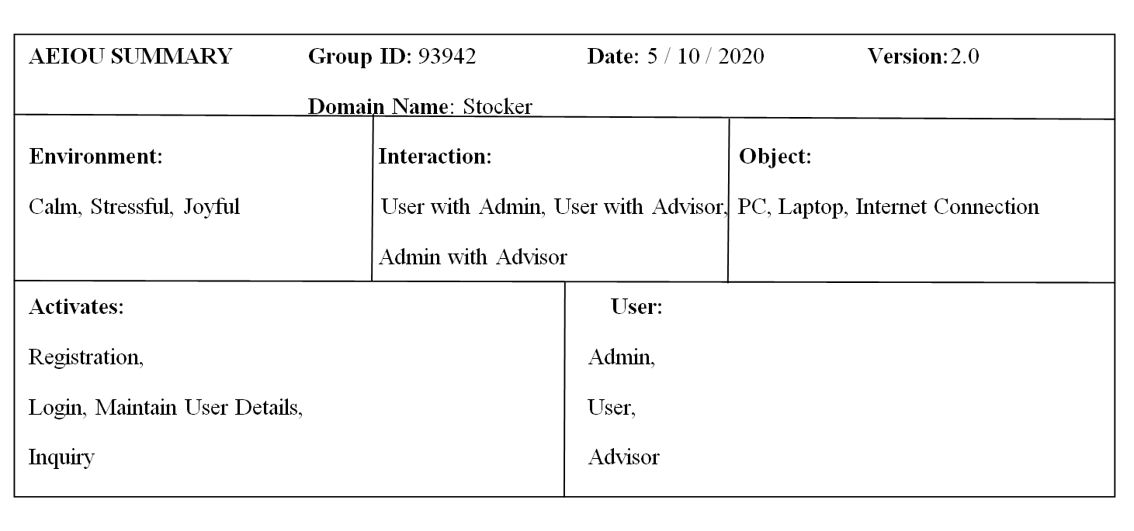

1. **Activities:**

Here in this section we have identified the activities in which the user were involved. It includes the general activities done by the users, elements and features which they have used during this activities.

* **The general impression shows:-**
* What is actually going on?
* Why is it going on?
* What elements are used during this activities?
* **Activities going on that time were:-**
* Registration
* Login
* Maintain user details
* Inquiry

1. **Environment:**

This is the second phase of observation.

* **It includes:-**
* Who are involved?
* Situation during observation
* Objects and things used
* **Environment during that time was:-**
* Calm
* Stressful
* Joyful

1. **Interaction:**

This is the third phase of observation.

* **It includes:-**
* Who are involved?
* What things is being discussed?
* With whom you are discussing?
* **The interaction carried out was:-**
* User With Admin
* User With Advisor
* Admin With Advisor

1. **Object:**

This is the fourth phase of observation

* **It includes:-**
* What components are used?
* What objects are used?
* How the object relate to their activities?
* **Objects used were:-**
* PC
* Laptop
* Internet Connection
* **Object relating to activities in these ways:-**
* CCTV recording the activities on the office

1. **User:**

This is the fifth phase of observation.

* Who is there?
* What’s their roles?
* **Some of the users are:-**
* Admin
* User
* Advisor

1. **Empathy Canvas**

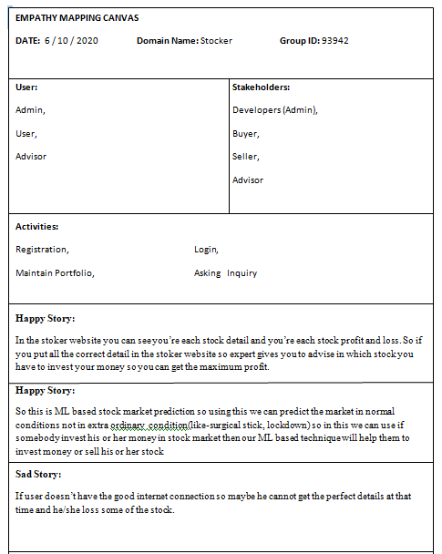

Empathy is the experience of understanding another person’s condition from their perspective.

It helps to understand the user more, within the context of our design challenges.

* **It includes:-**
* Admin
* User
* Advisor

Simply empathy means to understand someone’s problem and design the solution according to their needs.

* **Users include:-**
* Admin
* User
* Advisor
* **Stakeholders are:-**

* Developers (Admin)
* Buyer
* Seller
* Advisor
* **Activities done are:-**
* Registration
* Login
* Maintain portfolio
* Asking Inquiry
* **Story Boarding:**
* **HAPPY:**

In the stoker website you can see you’re each stock detail and you’re each stock profit and loss. So if you put all the correct detail in the stoker website so expert gives you to advise in which stock you have to invest your money so you can get the maximum profit.

* **HAPPY:**

So this is ML based stock market prediction so using this we can predict the market in normal conditions not in extra ordinary condition(like-surgical stick, lockdown) so in this we can use if somebody invest his or her money in stock market then our ML based technique will help them to invest money or sell his or her stock.

* **SAD:**

If user doesn’t have the good internet connection so maybe he cannot get the perfect details at that time and he/she loss some of the stock.

* **SAD:**

If user won’t to login this website then user need a good inter connection, laptop/pc or phone to run this website. If user does not have any of these then they cannot run this website.

1. **Ideation Canvas**

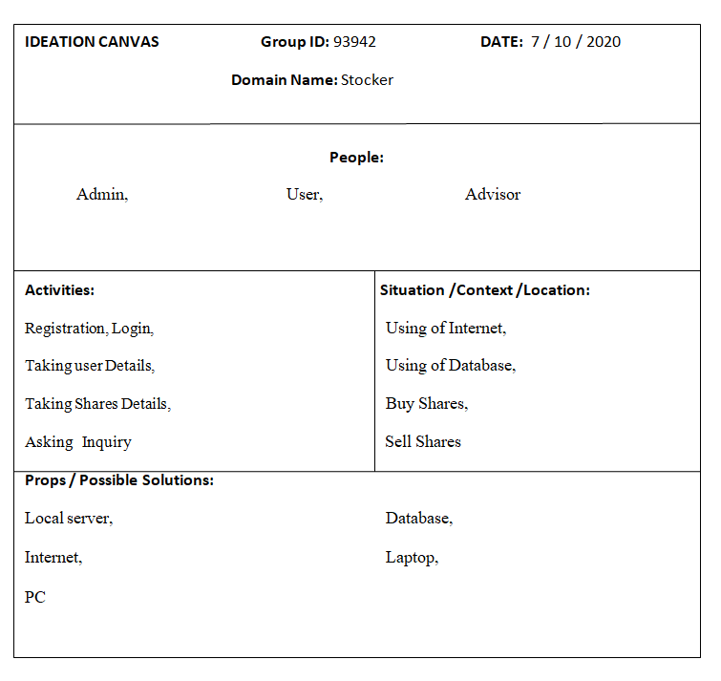

Ideation is a process of generating, developing and creating new ideas.

This idea is understood as a basic element of thought that can be visual, concrete or abstract.

Ideation is an essential part of design process, both in education and practice.

* **It includes:-**
* People
* Activities
* Situation/context/location
* Props/possible solution
* **People are:-**
* Admin
* User
* Advisor
* **Activities going on:-**
* Registration
* Login
* Taking User Details
* Taking Shares Details
* Asking For Inquiry
* **Situation/context/location:-**
* Using of Internet
* Using of Database
* Buy Shares
* Sell Shares
* **Props/Possible solution:-**
* Local server
* Database
* Internet
* Laptop
* PC

1. **Product Development Canvas**

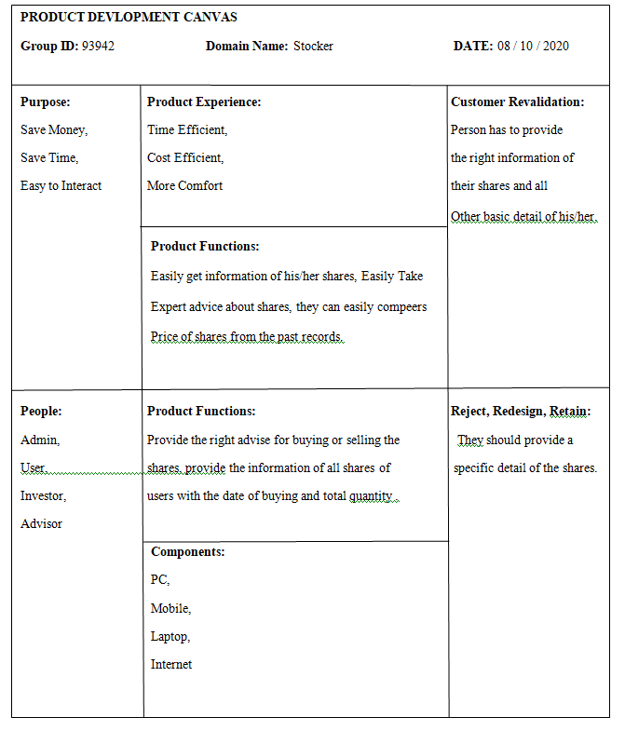

Product development is the process of designing, creating, marketing new products or services to benefit customers.

Product design is a prototype mode. The prototype mode is the iterative generation of artifacts intended to answer questions that get you closer to your final solution.

* **It includes:-**
* Purpose
* People
* Product Experience
* Product function
* Product features
* Components
* Customer revalidation
* Reject , Redesign , Retain
* **Purpose:-**

* Save Money
* Save Time
* Easy To Interact
* **People:-**
* Admin
* User
* Investor
* Advisor
* **Product Experience:-**
* Time Efficient
* Cost Efficient
* More Comfort
* **Product Functions:-**
* Provide car for renting
* Take online payment
* **Product Features:-**
* Easily get information of his/her shares,
* Easily Take expert advice about shares,
* They can easily compeers price of shares from the past records
* **Components used:-**
* PC
* Laptop
* Mobile Phone
* Internet
* **Customer Revalidation**
* Person has to provide the right information of their shares and all other basic detail of his/her.
* **Redesign**
* They should provide a specific detail of the shares

**Appendix B - System Design**

**(1)Use Case**

The purpose of the use case diagrams is simply to provide the high level view of the system and convey the requirements in laypeople's terms for the stakeholders. Additional diagrams and documentation can be used to provide a complete functional and technical view of the system.



**(2) Sequences Diagram**

A sequence diagram is a type of interaction diagram because it describes how—and in what order—a group of objects works together. These diagrams are used by software developers and business professionals to understand requirements for a new system or to document an existing process.

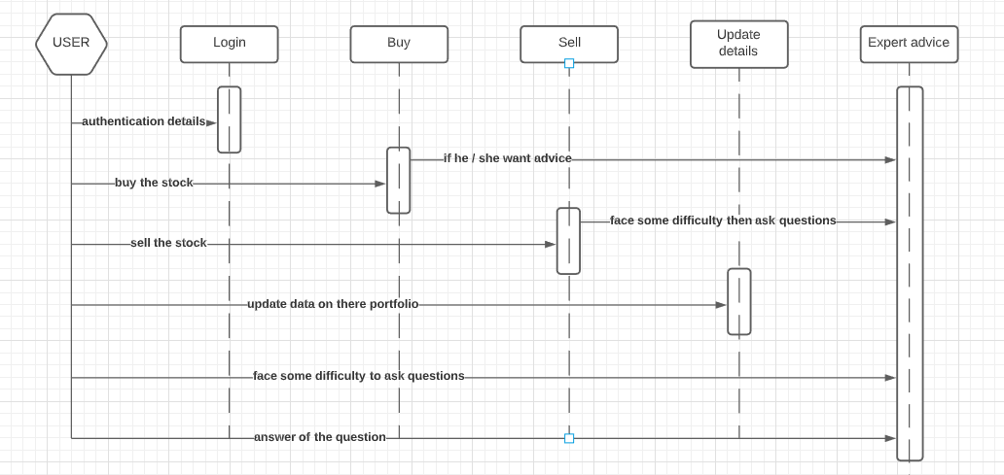

**(3)Class Diagram**

A sequence diagram is a type of interaction diagram because it describes how—and in what order—a group of objects works together. These diagrams are used by software developers and business professionals to understand requirements for a new system or to document an existing process.

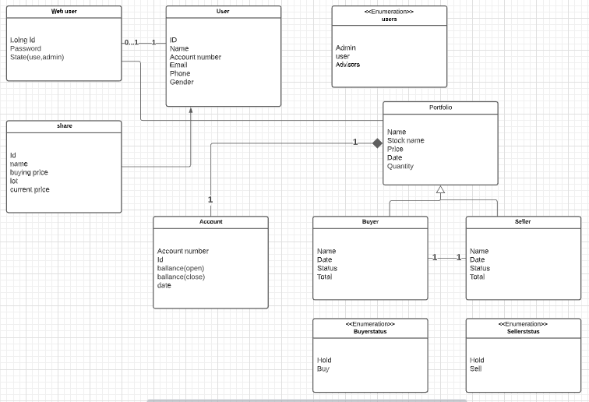

**(4)Activity Diagram**

An activity diagram is used to model the workflow depicting conditions, constraints, sequential and concurrent activities. On the other hand, the purpose of a Use Case is to just depict the functionality i.e. what the system does and not how it is done.

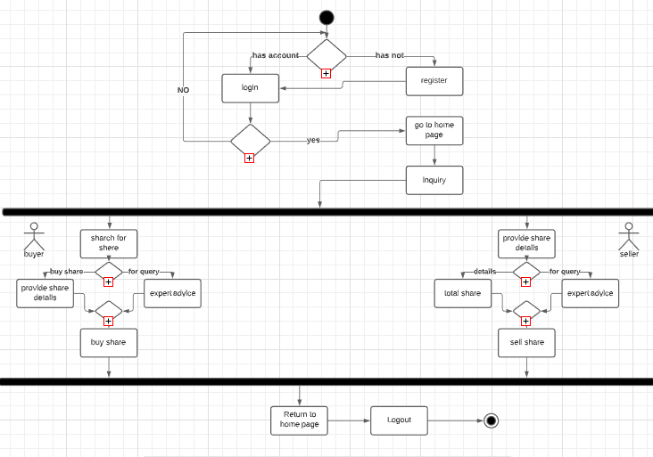

**(5)DFD**

A data flow diagram (DFD) maps out the flow of information for any process or system. It uses defined symbols like rectangles, circles and arrows, plus short text labels, to show data inputs, outputs, storage points and the routes between each destination.

1. **Level 0**

A level 0 data flow diagram (DFD), also known as a context diagram, shows a data system as a whole and emphasizes the way it interacts with external entities. This DFD level 0 example shows how such a system might function within a typical retail business.

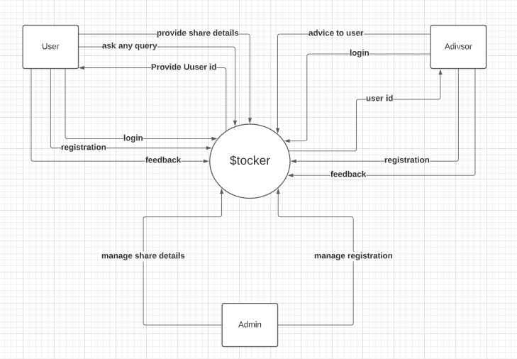

1. **Level 1**

A level 1 data flow diagram (DFD) is more detailed than a level 0 DFD but not as detailed as a level 2 DFD. It breaks down the main processes into subprocesses that can then be analyzed and improved on a more intimate level.

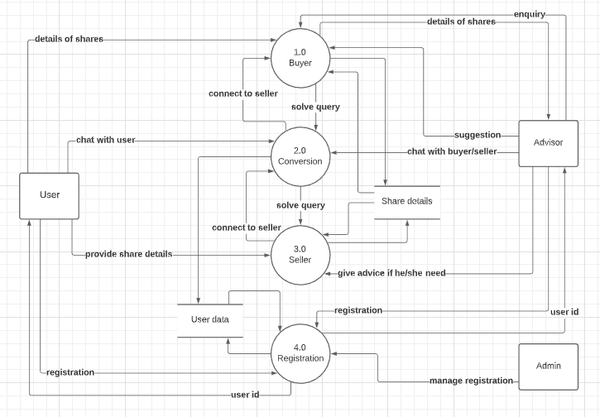

**Appendix C – Data Dictionary**

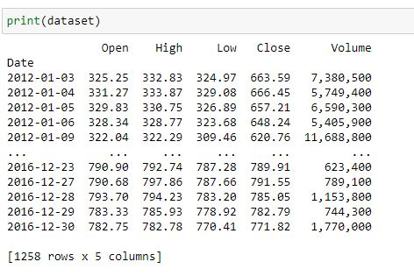

**Appendix D – Periodic Progress Reports**

**Periodic Progress Report 1**

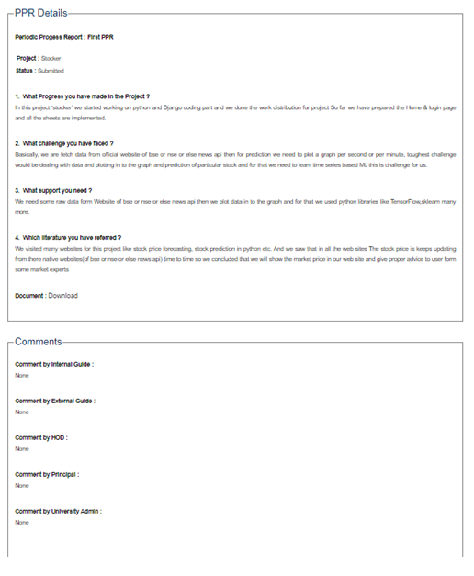

1. **What Progress you have made in the Project?**

In this project ‘stocker’ we started working on python and Django coding part and we done the work distribution for projectSo far we have prepared the Home & login page and all the sheets are implemented.

1. **What challenge you have faced?**

Basically, we are fetch data from official website of bse or nse or else news api then for prediction we need to plot a graph per second or per minute, toughest challenge would be dealing with data and plotting in to the graph and prediction of particular stock and for that we need to learn time series based ML this is challenge for us.

1. **What support you need?**

We need some raw data form Website of bse or nse or else news apithen we plot data in to the graph and for that we used python libraries like TensorFlow,sklearn many more.

1. **Which literature you have referred ?**

We visited many websites for this project like stock price forecasting, stock prediction in python etc. And we saw that in all the web sites The stock price is keeps updating from there native websites(of bse or nse or else news api) time to time so we concluded that we will show the market price in our web site and give proper advice to user form some market experts

**Periodic Progress Report 2**

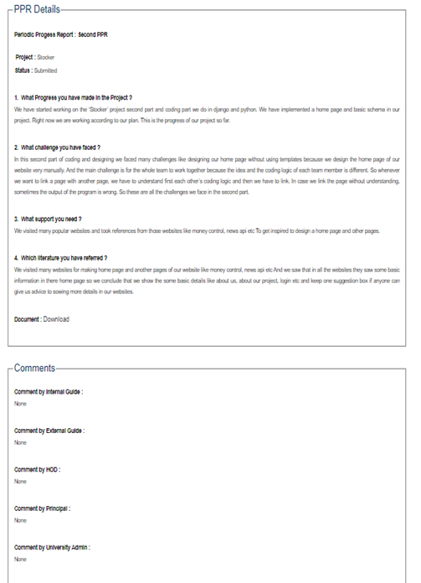

1. **What Progress you have made in the Project?**

We have started working on the ‘Stocker’ project second part and coding part we do in django and python. We have implemented a home page and basic schema in our project. Right now we are working according to our plan. This is the progress of our project so far.

1. **What challenge you have faced?**

In this second part of coding and designing we faced many challenges like designing our home page without using templates because we design the home page of our website very manually. And the main challenge is for the whole team to work together because the idea and the coding logic of each team member is different. So whenever we want to link a page with another page, we have to understand first each other’s coding logic and then we have to link. In case we link the page without understanding, sometimes the output of the program is wrong. So these are all the challenges we face in the second part.

1. **What support you need?**

We visited many popular websites and took references from those websites like money control, news apietc To get inspired to design a home page and other pages.

1. **Which literature you have referred ?**

We visited many websites for making home page and another pages of our website like money control, news apietc And we saw that in all the websites they saw some basic information in there home page so we conclude that we show the some basic details like about us, about our project, login etc and keep one suggestion box if anyone can give us advice to sowing more details in our websites.

**Periodic Progress Report 3**

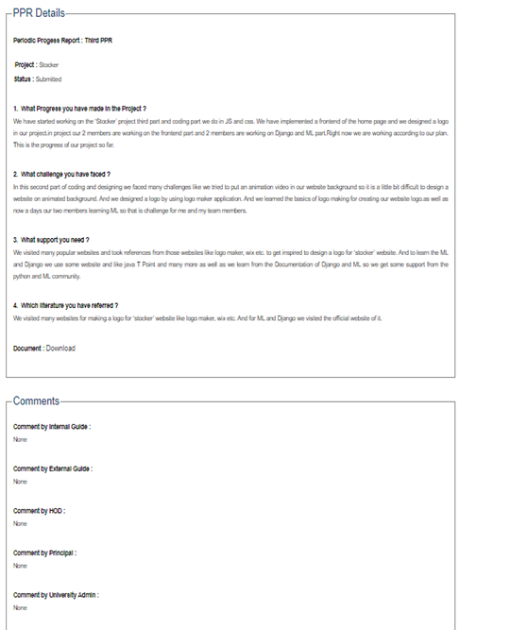

1. **What Progress you have made in the Project?**

We have started working on the ‘Stocker’ project third part and coding part we do in JS and css. We have implemented a frontend of the home page and we designed a logo in our project.in project our 2 members are working on the frontend part and 2 members are working on Django and ML part.Right now we are working according to our plan. This is the progress of our project so far.

1. **What challenge you have faced?**

In this second part of coding and designing we faced many challenges like we tried to put an animation video in our website background so it is a little bit difficult to design a website on animated background. And we designed a logo by using logo maker application. And we learned the basics of logo making for creating our website logo.as well as now a days our two members learning ML so that is challenge for me and my team members.

1. **What support you need?**

We visited many popular websites and took references from those websites like logo maker, wix etc. to get inspired to design a logo for ‘stocker’ website. And to learn the ML and Django we use some website and like java T Point and many more as well as we learn from the Documentation of Django and ML so we get some support from the python and ML community.

1. **Which literature you have referred?**

We visited many websites for making a logo for ‘stocker’ website like logo maker, wix etc. And for ML and Django we visited the official website of it.

**Periodic Progress Report 4**

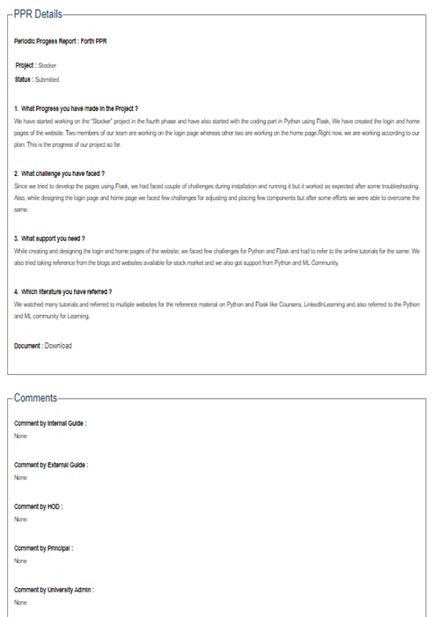

|  |  |
| --- | --- |
| **1) What Progress you have made in the Project?** | |
|  |  |

We have started working on the “Stocker” project in the fourth phase and have also started with the coding part in Python using Flask. We have created the login and home pages of the website. Two members of our team are working on the login page whereas other two are working on the home page.Right now, we are working according to our plan. This is the progress of our project so far.

**2) What challenge you have faced?**

Since we tried to develop the pages using Flask, we had faced couple of challenges during installation and running it but it worked as expected after some troubleshooting. Also, while designing the login page and home page we faced few challenges for adjusting and placing few components but after some efforts we were able to overcome the same.

**3) What Support you need?**

While creating and designing the login and home pages of the website, we faced few challenges for Python and Flask and had to refer to the online tutorials for the same. We also tried taking reference from the blogs and websites available for stock market and we also got support from Python and ML Community.

**4) Which literature have you referred to?**

We watched many tutorials and referred to multiple websites for the reference material on Python and Flask like Coursera, LinkedInLearning and also referred to the Python and ML community for Learning.

**Appendix E – Plagiarism Report**

